MAB260 Numerical Methods 2 – Coursework 1  
Error comparison when using Composite Trapezoidal Rule and Composite Simpson’s 3/8 Rule for numerical integration.

*Abstract*   
The general idea of numerical integration is to replace area under curve of a function f(x) by set of strips of width h, calculate the area of one strip then add the areas of all strips to obtain a numerical approximation of the integral. Composite Trapezoidal Rule and Composite Simpson’s 3/8 Rule are methods of numerical integration. This report investigates whether decreasing the strips width will reduce the errors of the approximations and compares the errors of the approximations obtained by these numerical integration methods using a computer algebra program, Maple.

*The task*  
To implement the Composite Trapezoidal and Simpson’s 3/8 rule into Maple, we need to define procedures which will integrate a given function *f(x)*, with input parameter, limits *a* and *b* and *n* strips.  
With the given function and input parameter, we would write a program which will repeatedly input these parameters into the procedure. We would obtain a set of results by changing the successively dividing the strip width by 3 (increasing n by 3n). Lastly, using the results to plot the absolute value of the errors of the result over the strip width h in a log-log plot.

*Method of solutions*  
For both procedure, *f*, *a*, *b*, and *n* are the input parameters for both rules. (See line 1 of [1] & [2] in Maple Listing.) Using the formulae that defines these numerical integrations, we will break down the formulae into operation steps so that we can write it into the procedure.  
The Composite Trapezoidal Rule is defined as follows:   
 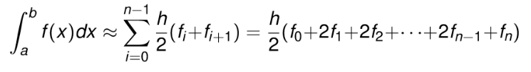  
where , n = the number of strips and function value .  
In the Trapezoidal Rule procedure ([1] in maple listing), we can define h as it is above since *b*, *a*, and *n* are already defined as input (see line 3 of [1]) and introduce a new variable S which will store the summation of the function values. We can see that this formula is the sum of f0 to fn multiplied by h/2 where f1 to fn-1 are multiplied by 2. To make the program simpler, notice that when we multiply h/2, f0 & fn is halved and the multiple of 2 of f1 to fn-1 are cancelled out. To calculate S, we add the sum of f0 & fn to S, multiply S by ½. (see line 4 of [1]). Then, add f1 to fn-1 to S which can be achieve by a ‘for’ loop where the loop will successively adding the next term to S until n-1. (see line 5-7 of [1]). Multiply S by h to finish replicating the rule. (see line 8 of [1]).

The Composite Simpson’s 3/8 Rule is defined as follows:  
 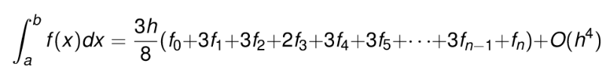  
In the Simpson’s 3/8 Rule procedure ([2] in maple listing), we can define h as we did before and a variable S as the summation of function value. Similar to Trapezoidal Rule, we calculate S by adding of f0 & fn first to S (see line 5 of [2]) and using a ‘for’ loop to sum up all the other values. However, there are a few differences in the formula compared to Trapezoidal rule. From f1 to fn-1, every third term in the sequence is multiplied by 2 while all other are multiplied by 3. This can be replicated using an ‘if’ statement in Maple. (See line 7-11 of [2]). Multiply S by h and 3/8 to finish. (See line 12 of [2])  
All procedures use 20 digits in the calculation.  
To obtain a set of results, define the input parameters, *f, a,* and *b* in Maple first. Then, create a simple ‘for’ loop program with variables containing the result of procedures of the current ‘n’ input, printing the result on screen and changing the ‘*n’* input parameter for every iteration. (see [4] in Maple listing)

*Results and Discussion*

In order for these procedure to generate results, we define inputs for the procedures.   
Function used is  (see [3] in Maple listing), b = 8.0, .  
The exact value of the integral is 0.36043691956310767399. (see [5] in Maple listing for method)  
Starting with n=3, by increase the value of n by 3n (dividing the strip width by 3)   
we obtain the following results:

|  |  |  |  |
| --- | --- | --- | --- |
| n | h | Trapezoidal Result | Simpson’s 3/8 Results |
| 3 | 2.525318 | 1.0198603946271427761 | 0.7528904631413716144 |
| 9 | 0.841773 | 0.40617899769929107609 | 0.32946882308330961361 |
| 27 | 0.280591 | 0.36525130689426223807 | 0.36013534554363363331 |
| 81 | 0.093530 | 0.36096895421664030218 | 0. 3604336601319375602 |
| 243 | 0.031177 | 0.36049599922287180928 | 0.36043687984865074786 |
| 729 | 0.010392 | 0.3604434835345531301 | 0.36043691907351329525 |

From the results, we can see that as the strip width decreases, the accuracy of the results improves, the errors of the results decreases. This can be seen by comparing the results with the exact value of the integral (similar values are indicated by red).

The log-log plot on the left further illustrate this pattern.  
See [6] and [7] in Maple listing for the method of working out the absolute value of the error and computation of plotting the log-log graph.

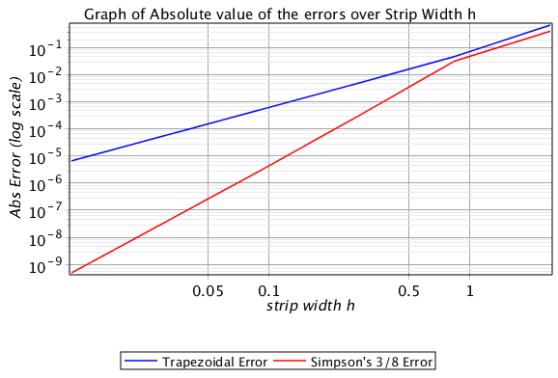

From the graph, we can see that Trapezoidal error decreases at a constant rate and Simpson’s 3/8 error is always less than Trapezoidal error.

With the Simpson’s 3/8 error, while strip width is greater than 1, the error decreases at the same rate as Trapezoidal error. After the strip width reaches around 0.75, the error start to reduce at a faster rate compare to Trapezoidal error.

This suggest that using the Simpson’s 3/8 rule will obtain a better approximation compared to Trapezoidal rule while strip width is less than 0.5.

*Conclusion*  
From the results obtained, we can conclude that as strip width decrease, the error decreases for both methods of numerical integration. Comparing these two sets of results, we observed that using Simpson’s 3/8 Rule for numerical integration will obtain a better approximation compare to trapezoidal rule. For strip width less than 0.5, Simpson’s 3/8 rule will obtain an approximation very close to the exact integral. Overall, as strip width decreases, Composite Simpson’s 3/8 rule is a better numerical integration method compare to Composite Trapezoidal Rule when we want a close approximation to the integral.